**C .V**

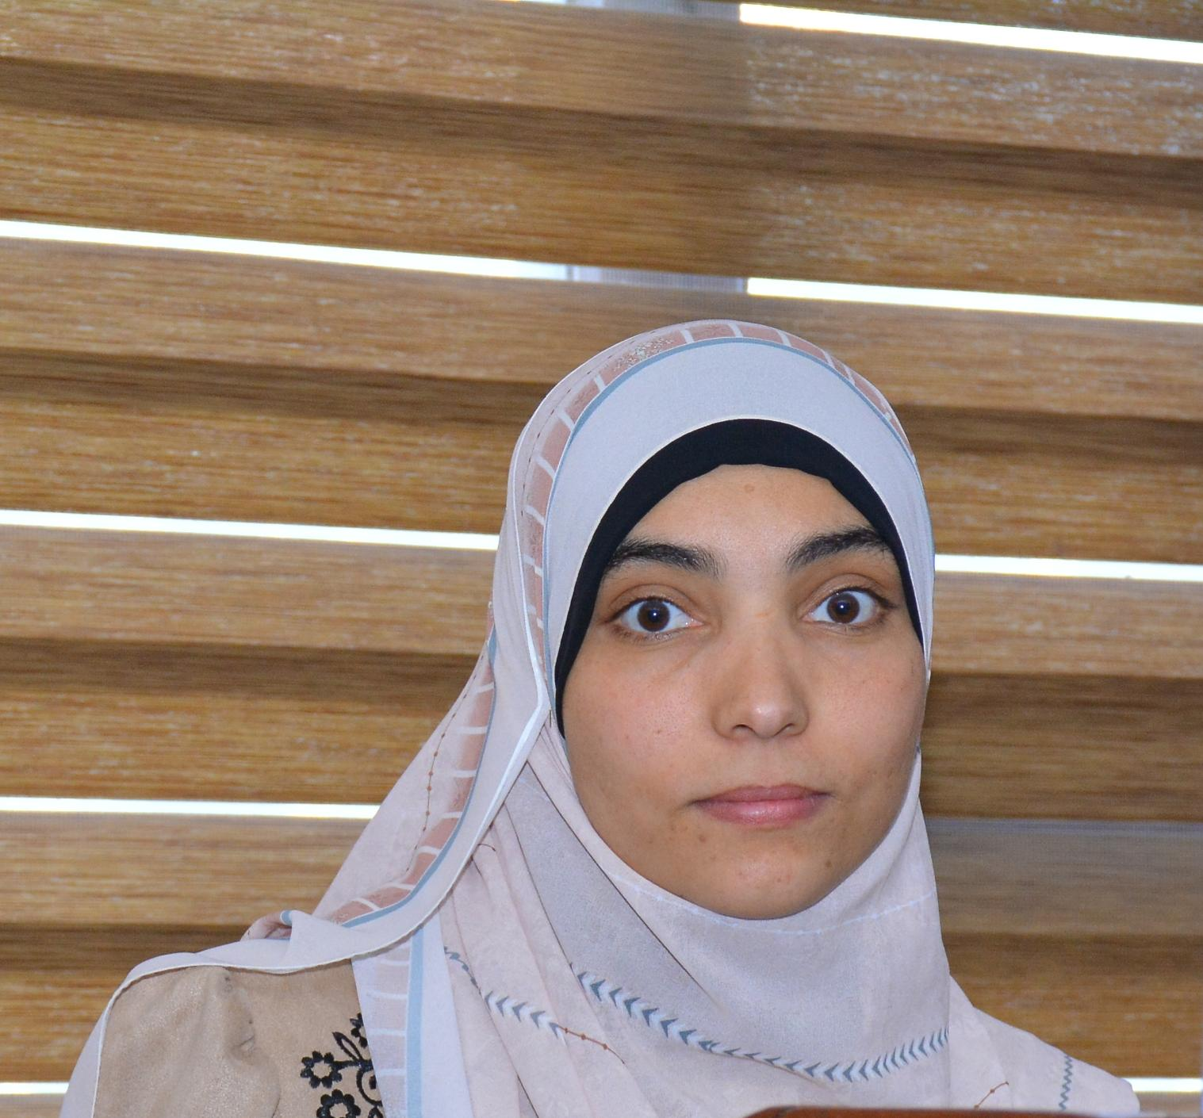

**Hanan Faried Maghawry Mahrous**

Personal Data:

Name: **Hanan Faried Maghawry Mahrous**

Date and place of birth: 5-11- 1991. Assiut,Egypt.

Nationality: Egyptian.

Address: Psychiatric Nursing Department, Faculty of Nursing,

Assiut University, Assiut- Manfalout.

Religion: Muslim

Present address: Assiut University, Assiut.

Telephone: 011 43055641- 01003169597

E-mail: hananfaried91@aun.edu.eg

hananfaried91@Gmail.com

Languages:

* **Mother language:** Arabic
* **Foreign languages:** English

Present Position:

Lecturer of Psychiatric and mental health nursing department, Faculty of Nursing, Assiut University 2024.

Previous Positions;

- **Internship,** (September 2013 – August 2014), Assiut University Hospital this included:

- One month in intensive trauma unit.

- One month in trauma unit.

- One month in operating room.

- One month in burn unit.

- One month in pediatric intensive unit.

- One month in premature unit

- Two months in obstetric

- One month in oncology unit

- One month in intensive medical unit

- One month in CPR

- One month in Administration

**-Resident:** in female psychiatric unitin Neuropsychiatry, Assiut University Hospital,

From 2016 to 1 November 2018.

-**Demonstrator** in psychiatric and mental health nursing, Assiut University, From Abril 2015 to the end of 2019.

Educational Qualifications:

* **Bachelor's degree of nursing** – faculty of Nursing- Assuit university (Excellent with honour, 2013).
* **Master of in psychiatric nursing:** Faculty of nursing, Assiut University.

(Very Good, 2019).

**Theses: Master’s thesis (MSc) in psychiatric nursing**, Thesis title “Effect of psychoeducation program on Anxiety, Depression and Pain among patients undergoing knee and hip replacement surgery”. Assiut University, 2019 (Excellent).

**Doctoral thesis (PHD) in psychiatric nursing.** Thesis title “Effect of Emotional Intelligence Program on Addict patients at Assiut University Hospital”.

The published research:

Effect of psychoeducation program on Anxiety, Depression and Pain among patients undergoing knee and hip replacement surgery” volume 7. Issue 16. March (2019). *Assiut Scientific Nursing Journal*.

‏

**Teaching Courses:**

**Courses for Undergraduate:** Psychiatric and mental health course (clinical) for fourth year students in faculty of nursing till now

**Courses for intensive program:** Psychiatric and mental health course (clinical) for six level.

**Membership of Scientific and quality Committees and other responsibilities:**

* Member of postgraduate committee at quality unit, Faculty of nursing - Assiut University.
* Assistant Coordinator of Master Program New Rules at Faculty of nursing - Assiut University**.**
* Coordinator of quality of postgraduate program in Psychiatric and Mental health department.
* Responsible for arranging In-Box and Out-Box folders in Psychiatric and Mental health department.
* Responsible for arranging council department folder in Psychiatric and Mental health department**.**

Important Conference Attendance:

* 2nd scientific day of psychiatric nursing department, Assiut University “Addiction, Its dangers and its ways for treatments” 7- March 2017.
* 2nd scientific day of Pediatric Nursing Department “Common Mistakes in Nursing research” 15 November 2017.
* 3rd scientific day of psychiatric nursing department, Assiut University “Cosmic energy science and its relationship to mental health” 4 March 2019.

- 1st internationalupper Egypt nursing colleges conference, 2nd international conference of nursing colleges,Assiut University (toward achieving sustainable development goals: quality education and health, 23-25 Feb 2020.

* 1st scientific course and workshop of diabetic foot , prevention of diabetic foot Amputation: multidisciplinary approach 16 Jan 2020.
* 2nd international upper Egypt nursing colleges conference, 4th international conference of nursing colleges,Assiut University, (Together for health promotion) 13-14 Feb 2022.
* 4th scientific day of community health nursing & psychiatric nursing department, faculty of nursing, Assiut University, (social media and its impact on community and mental health 4 Dec 2022.
* 3rd Internationalupper Egypt nursing colleges conference, Assiut University (Environmental health and safety) 19-20 Feb 2023.
* Attending workshop of mendaly, July 2023.

Courses:

* Infection Control, 2013.
* Preparation of the university teacher, 2016.
* ICDL (International Computer Driving License).
* Services of Academic E-mail office 365, 2018
* Training program of " Communication skills" 2018.
* Training program of " Ethics of scientific research" 2018.
* English Language Professional Test (ELPT), 2020
* Self-Evaluation for Faculty of Standards Accreditation Faculties., 2021.
* Self-Evaluation for University of Standards Accreditation Universities., 2021
* Training program of " Recent Trends in the development of higher Educational Institutions” 2022.
* Training program of “Publications of research in international journal” 2023.
* Training program of " How to Design The E-Course", 2023
* Training program of “Management of crises” July 2023.
* Training program of “Organizing Scientific conferences”, 2023.

Professional Skills:

* Excellent in English and Arabic: oral and written.
* Preparing time academic schedules.
* Operating Systems: Microsoft Windows 95, 98, 2000, XP, and 2003, 2007, 2010.
* Word processing software: WordPerfect 10, Microsoft Word, XP and 2003, 2007, 2010.
* Presentation software: Microsoft Power Point XP and 2003, 2007, 2010.
* Data entry and analysis: Statistical Package for the Social Sciences (SPSS version 11.5, SPSS Inc., Chicago, Illinois),
* Internet: Internet Explorer, Google.

**Community service work:**

- Participation in vaccination campaigns against the Corona virus at the Faculty of Nursing, Assiut University, 2022

|  |
| --- |
|  |